# SOP - Correlate Manifest to Commits & JIRA tickets

Pre-requisite: JIRA ticket id should be included in the PR.  Preferred formatting is '[<ticket-ID>] Brief Description'

* **Shortcut for finding checkins in rolled out manifest**
  + <http://go/pulse> -> Core Product -> “Grid Icon”

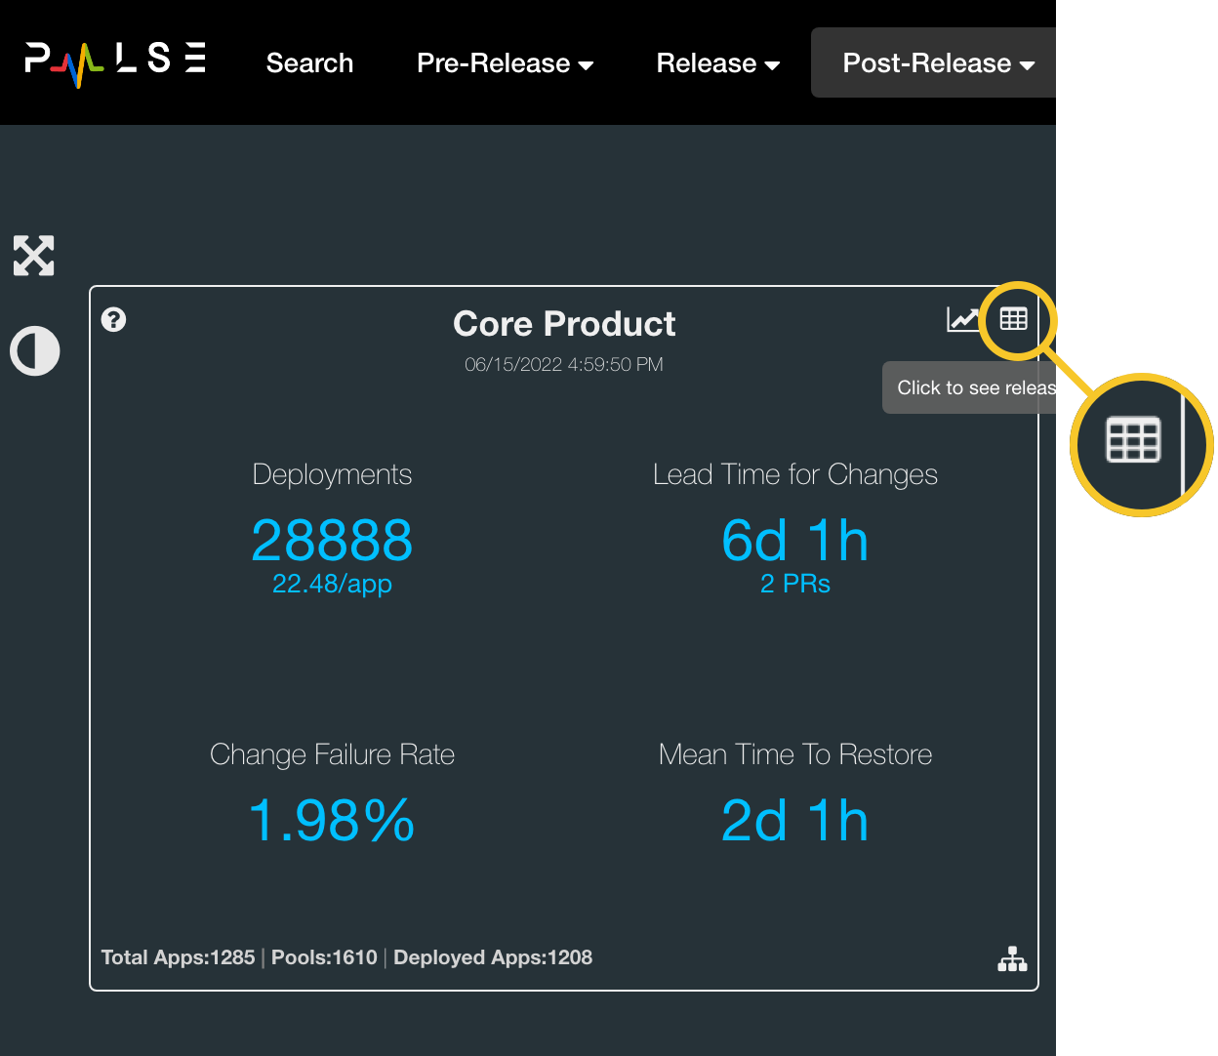

* + Select desired
  + Expand "**Change creation**" to view included Pull Requests and JIRA ticket ids.

